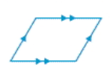
Parallelograms
Definition: A quadrilateral with both pairs of Opposite Sides are Parallel
- Both pairs of Opposite Sides are congruent
- Opposite Angles are congruent
- Consecutive Angles are Supplementary
- Diagonals bisect each other

Rectangles Rhombus
Definition: A parallelogram with four right angles (equiangular parallelogram)
- Diagonals are congruent

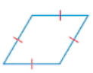
Definition: A parallelogram with all Sides are congruent (equilateral parallelogram)
- Diagonals are perpendicular
- Diagonals bisect the opposite angles

Squares
Definition: A regular parallelogram
- All properties of Parallelograms
- All properties of Rectangles
- All properties of Rhombus

